Chapter 9: Alkynes Review Packet

**Preparation of Alkynes**

Dehydrohalogenation can also occur, in which a hydrogen and halogen are removed in order to form a double bond between adjacent carbons.

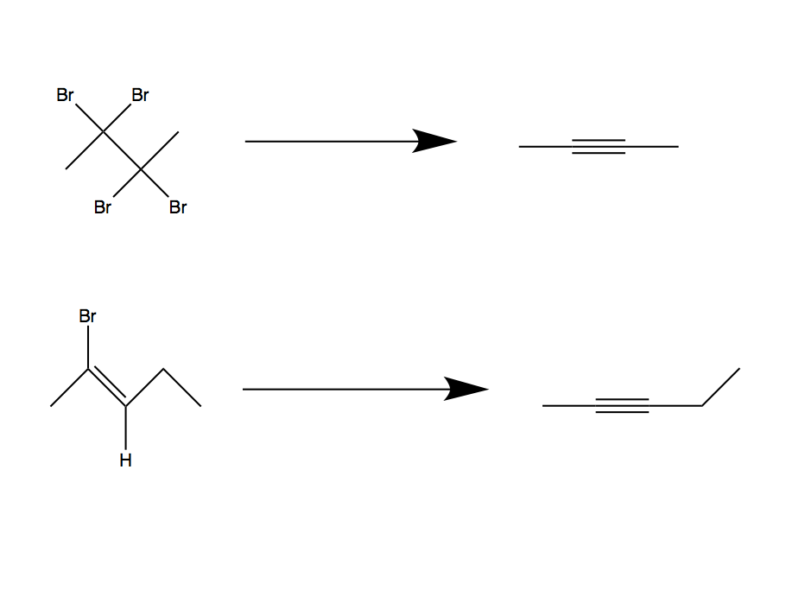

1. 2NaNH2

2. H3O+

H

H

**Alkyne Reactions**

1. Halogenation

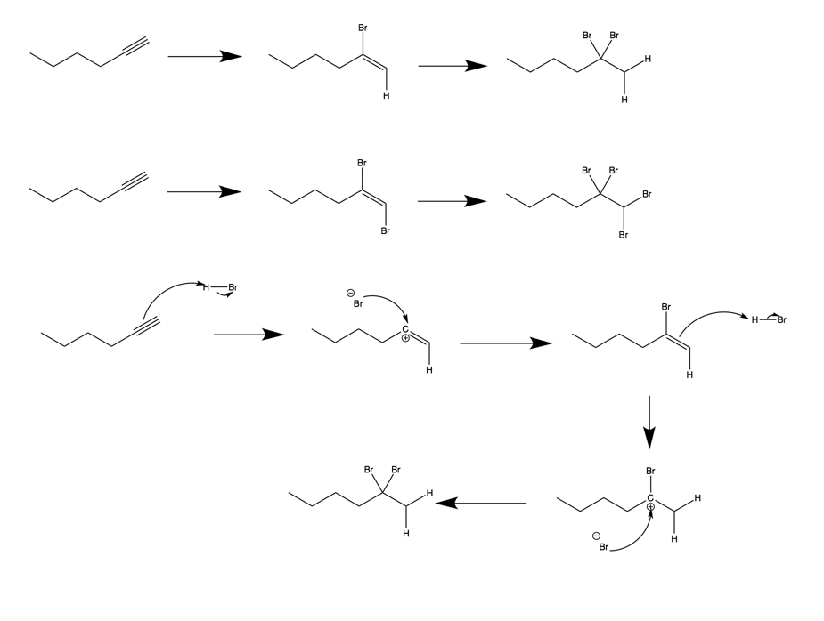

Br2

Br2

HBr

HBr

Halogenation can occur with hydrogen halides or with diatomic halides. The pi bonds will be broken in both reaction types (assuming multiple equivalents are used) while the products look slightly different, as shown above.

Mechanism:



1. Hydration
   1. Mercury Catalyzed Hydration

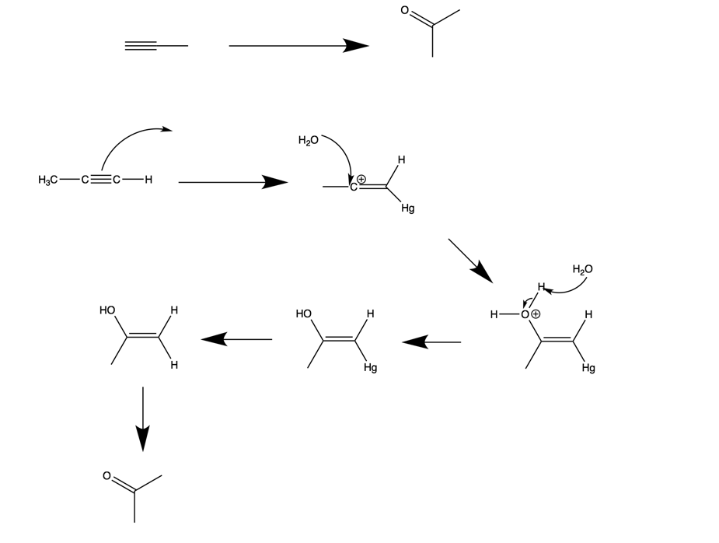

H2O, H2SO4

HgSO4

Mechanism:



Mercury catalyzed hydration adds a hydroxyl group to the more substituted carbon in the alkyne. When this happens, one pi bond breaks, leaving an alkene functional group. When the hydroxyl group attaches, the molecule will tautomerize (rearrange to a more stable form) to form a carbonyl as opposed to an alkene. Carbocations are also formed as intermediates in the reaction.

Tautomerization

2+SO42-

2+SO42-

2+SO42-

Hg2+SO42-

* 1. Hydroboration

Hydroboration occurs similarly to alkene hydroboration. A hydroxyl group attaches to the least substituted carbon. When this happens, one of the pi bonds in the alkyne is broken, leaving an alkene functional group. The molecule will tautomerize to form a carbonyl group. Boron can also be bound to up to 3 reactant molecules (if they are small) at one time.

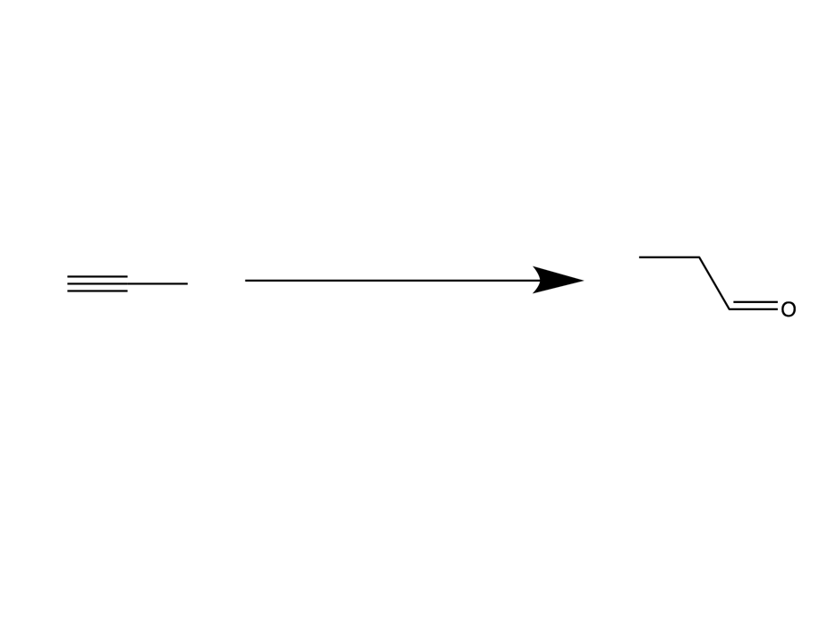

1. BH3, THF
2. H2O2
3. Reduction (Hydrogenation)

Hydrogenation using platinum or palladium as a catalyst with diatomic hydrogen (used in excess) will completely reduce both of the pie bonds in the alkyne, forming an alkane.

* 1. Alkane Formation

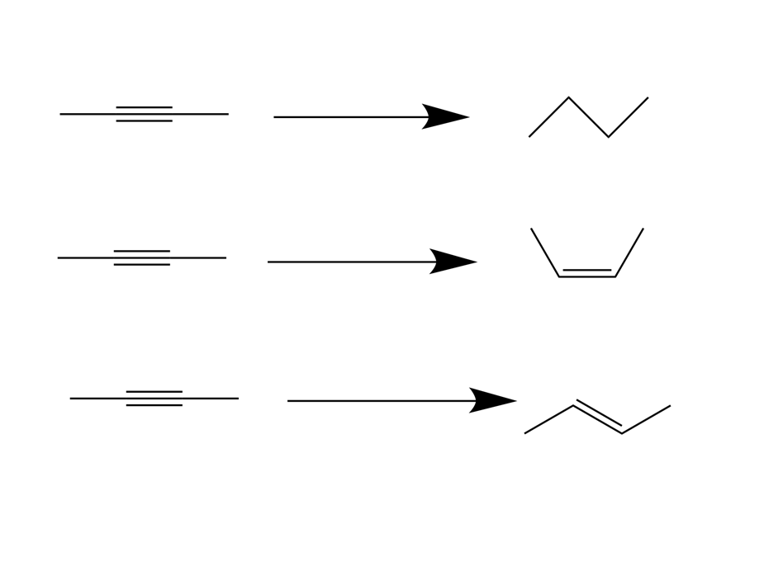

H2 / PtO2

CH3CO2H

* 1. Lindlar’s Catalyst (Cis- alkene formed)

Hydrogenation with a Lindlar catalyst will reduce the alkyne only to an alkene, and it will produce a cis- alkene product.



Lindlar Catalyst

H2

* 1. Li-NH3 Reduction (Trans- alkene formed)

Hydrogenation with lithium will result in alkene that is in the trans- configuration.



NH3

Li

Mechanism:

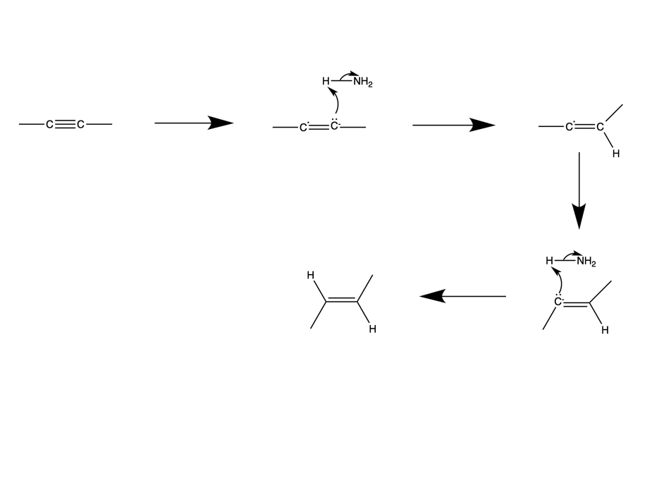

-

-

Li

Li

1. Oxidation
   1. Ozonolysis AND Permanganate Cleavage (the products will be the same for both)

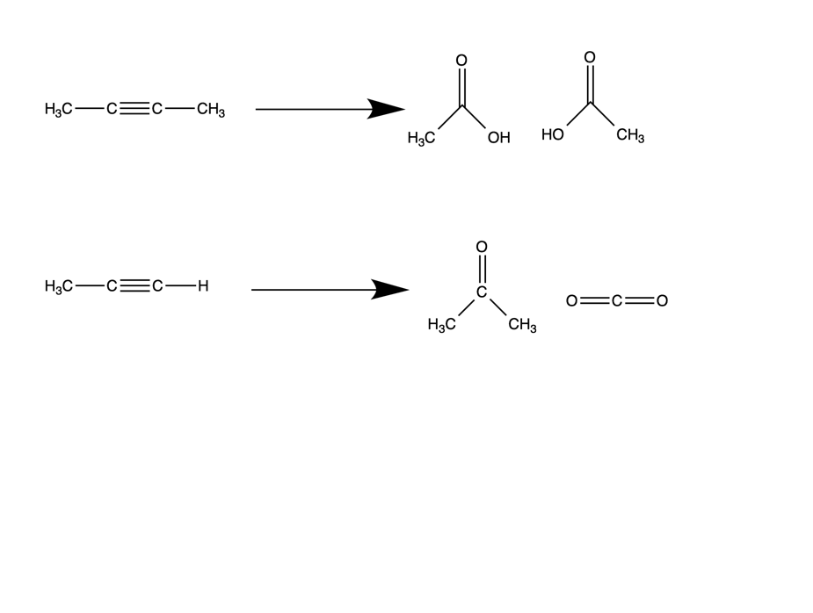

OH

Oxidation of a terminal alkyne will result in the formation of one carboxylic acid and one CO2 molecule.

Oxidation of an internal alkyne will result in the formation of two carboxylic acids.

O3 OR KMnO4

O3 OR KMnO4

1. Alkyne Acidity

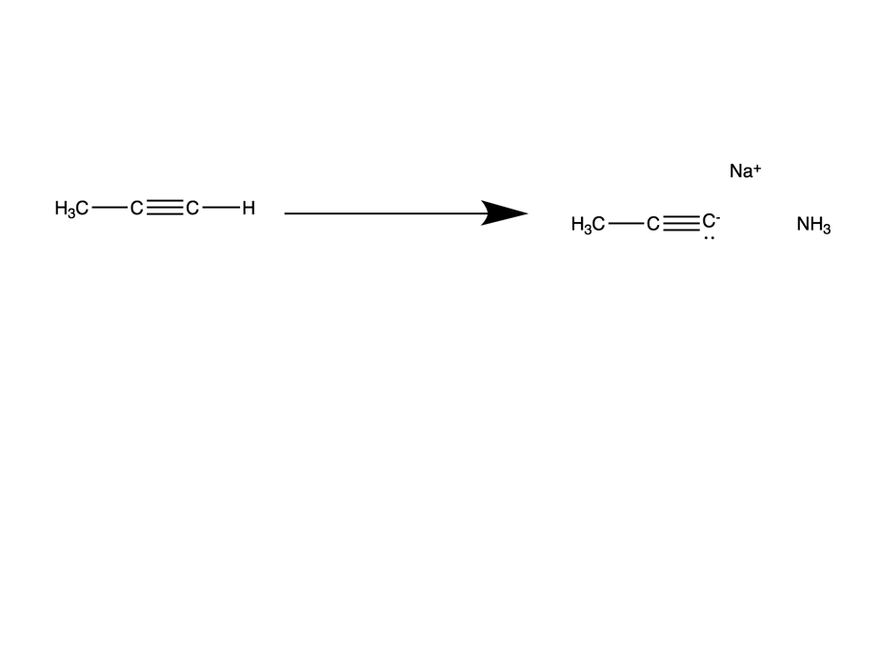

-

Terminal alkynes are slightly acidic, and can rather easily give up the terminal hydrogen, forming an acetylide anion. From this anion state, organohalides and other functional groups can be added on to the alkyne.