Chapter 11 Review Packet

**SN2 Reactions**

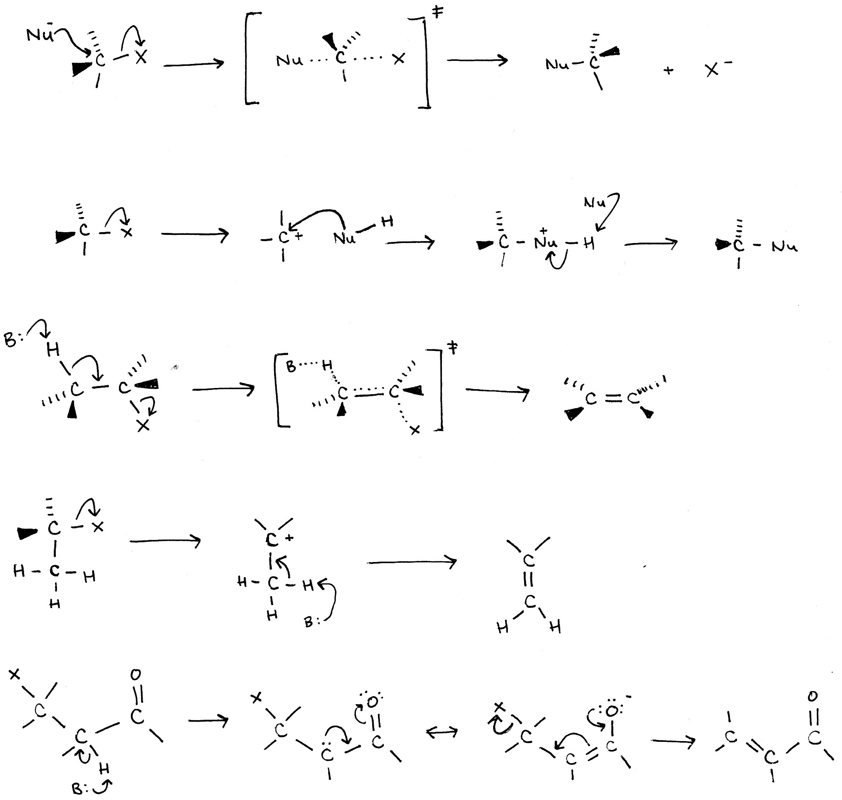

SN2 reactions were named with the S standing for “substitution”, the N for “nucleophilic” and 2 for “bimolecular”, because two molecules are interacting in the rate-limiting (“slow”) step of the reaction. In the mechanism, the Nucleophile (Nu) attacks the carbon from one side of the molecule, opposite from the leaving group (X), resulting in an **inversion of configuration**. The inversion of configuration will lead to an inversion in the designated configuration (R or S) at the carbon, only if the carbon is a chirality center.

A Nucleophile is typically stronger the more negatively charged it is. Elements farther down groups in the periodic table are typically better Nucleophiles. Also, basicity is relatively related to efficiency of a nucleophile (more basic, better nucleophile). (* is the best)

**Nucleophile**

H2O

CH3COO-

H3N

Cl-

OH-

CH3O-

I-

CN-

SH-

N3-*

**Substrate**

Methyl > 1° > 2° > 3°

The SN2 reaction prefers substrates with lower substitution values so there will be less steric strain in the transition state of the reaction.

**Leaving Group**

OH-, NH2-, OR- < F- < Cl- < Br- < I- = TosO-

Leaving groups are better the less electronegative they are, so the bond from the leaving group to the carbon can be broken more easily, which is why Fluorine is a terrible leaving group (it is the most electronegative element).

The solvents for SN2 reactions are best if they are polar aprotic, because they don’t solvate the nucleophile, therefore hindering the nucleophile and slowing the reaction (like protic solvents). Solvents that can hydrogen bond would result in a slower rate. (* is the best solvent)

**Solvent**

CH3OH

H2O

DMSO

DMF

CH3CN

HMPA*

**SN1 Reactions**



The SN1 reaction is very similar to the SN2, although it is unimolecular, meaning that it only involves one molecule in the rate-limiting (“slow”) step. The rate limiting step is the first step, where the leaving group (X), spontaneously breaks free from the carbon it was attached to. After this step, a carbocation is generated, that can then be attacked by a negative or neutral nucleophile. The nucleophile can attack from either face (remember the Si and Re faces), although it may have a slight preference for the face opposite of the leaving group (once the leaving group breaks off, it may still be close to the carbocation). Both of the configurations are produced. If the nucleophile is now positively charged, another nucleophile or base can perform a nucleophilic attack on the hydrogen, resulting in a neutral substitution product.

A Nucleophile is typically stronger the more negatively charged it is. Elements farther down groups in the periodic table are typically better Nucleophiles. Also, basicity is relatively related to efficiency of a nucleophile (more basic, better nucleophile). (* is the best)

**Nucleophile**

H2O

CH3COO-

H3N

Cl-

OH-

CH3O-

I-

CN-

SH-

N3-*

**Substrate**

Methyl < 1° < 2° < 3°

The SN1 reaction prefers substrates with higher substitution values so the carbocation intermediate will be stabilized. If the carbocation (in the transition state) is not on a tertiary carbon, an alkyl or hydride shift may occur to form a tertiary carbocation.

**Solvent**

The solvents for SN1 reactions are best if they are protic, so they can stabilize the carbocation intermediate through hydrogen bonding. Water and ethanol are both good solvents for SN1 reactions; with water being better than ethanol (water has a higher number of hydrogens).

**Leaving Group**

OH-, NH2-, OR- < F- < Cl- < Br- < I- = TosO- < H2O

Leaving groups are better the less electronegative they are, so the bond from the leaving group to the carbon can be broken more easily, which is why Fluorine is a terrible leaving group (it is the most electronegative element). Water can be a good leaving group for SN1 reactions.

**E2** **Reactions**



E2 reactions are bimolecular, as they have two molecules (a base and a substrate) interacting in the slow step of the reaction. The base in the reaction pulls off the proton, and the carbon to hydrogen bond breaks. The electrons in the carbon to hydrogen bond then form a pi bond, with an adjacent carbon, that then kicks off a leaving group (X). The transition state involves the carbon to hydrogen and carbon to leaving group bonds breaking, while the carbon to carbon pi bond is forming. An alkene is formed from the original substrate, usually with the more substituted alkene formed (due to Zaitsev’s rule). E2 reactions also require AP geometry, meaning antiperiplanar. The leaving group and adjacent hydrogen must be opposite from one another in the same plane. In a cyclohexane, where a chair conformer can be drawn, the leaving group and AP adjacent carbon must be in the axial positions to be truly opposite from one another in the same plane (which can be visualized by Newman projections). Also, the leaving group and the adjacent hydrogen must be opposite within the same plane, because the sp3 lobes will become π lobes to form the pi bond. When considering the stereochemistry of the product, the reactant must be observed. If the two high priority groups are on the same side of the molecule (cis-) to one another in the reactant, a Z product will be formed. In a molecule where AP geometry cannot be maintained while meeting Zatisev’s rule, the AP geometry takes precedence.

The Deuterium Isotope Effect:

Carbon to hydrogen bonds were replaced with carbon to deuterium bonds in a substrate molecule. An E2 reaction was performed, and the reaction rate was slower than when only carbon to hydrogen bonds were present, meaning that the carbon to hydrogen bond is broken in the rate determining step.

**Base**

OR-, CH3O-, EtO-, NH2-, OH- are all (strong)bases that can be used in the E2 reaction. Strong bases are needed in order to pull the hydrogen off of the carbon, and initiate the flow of electrons to for the pi bond and break the carbon to leaving group bond.

**Leaving Group**

OH-, NH2-, OR- < F- < Cl- < Br- < I- = TosO- < H2O

Leaving groups are better the less electronegative they are, so the bond from the leaving group to the carbon can be broken more easily, which is why Fluorine is a terrible leaving group (it is the most electronegative element).

**Solvent**

The solvents for E2 reactions are best if they are protic. Water and ethanol are both good solvents for E2 reactions; with water being better than ethanol (water has a higher number of hydrogens).

**Substrate**

Methyl < 1° < allylic/benzylic < 2° < 3°

The E2 reaction prefers substrates with a higher substitution value, because the higher substituted alkene is formed (Zaitsev’s rule). A more substituted alkene is more stable, and, therefore, more favorable. However, in one scenario, a primary substrate can be used in combination with a very bulky (large) base in order to yield an E2 product.

**E1 Reactions**



E1 reactions, similarly to E2 reactions, result in an alkene product. The mechanism, however, is very similar to SN1 reactions (the rate limiting step only involves one molecule, and a carbocation intermediate is formed). The leaving group spontaneously leaves, resulting in the formation of a carbocation intermediate. The hydrogen on an adjacent carbon is attacked by a base, which initiates the formation of a pi bond. Due to the similarity between the E1 and SN1 mechanisms, these two kinds of reactions typically occur simultaneously. E1 reactions do not require AP stereochemistry. The only rule that applies to E1 reactions is Zaitsev’s rule, dictating that the more substituted alkene is formed.

**Substrate**

Methyl < 1° < 2° < 3°

The E2 reaction prefers substrates with a higher substitution value, because the higher substituted alkene is formed (Zaitsev’s rule). A more substituted alkene is more stable, and, therefore, more favorable.

**Base**

Weak or even slightly acidic bases are used in the E1 reaction, to avoid performing an E2 reaction (which requires a strong base). Also, strong bases can be used, but they must be very dilute.

**Solvent**

The solvents for E1 reactions are best if they are protic. Water and ethanol are both good solvents for E1 reactions; with water being better than ethanol (water has a higher number of hydrogens).

**Leaving Group**

OH-, NH2-, OR- < F- < Cl- < Br- < I- = TosO- < H2O

Leaving groups are better the less electronegative they are, so the bond from the leaving group to the carbon can be broken more easily, which is why Fluorine is a terrible leaving group (it is the most electronegative element).

**E1cB Reactions**



The E1cB reaction proceeds through a carbanion, as opposed to the carbocation seen in the transition state of E1 reactions. This reaction mainly occurs when the leaving group is two carbons away from a carbonyl functional group. The E1cB reaction is more typical in molecules that contain poor leaving groups, such as oxygen in nitrogen substituents. The poor leaving group won’t undergo an E1 or E2 reaction, but it will help to make the adjacent hydrogen more acidic, as the electrons will be pulled towards the electronegative oxygen atom. Once the acidic hydrogen is pulled off, the anion is formed. The resonance forms of the anion result in the formation of a pi bond and the ultimate breaking of the leaving group to carbon bond.