Chapter 8: Alkenes Review Packet

**Preparation of Alkenes**

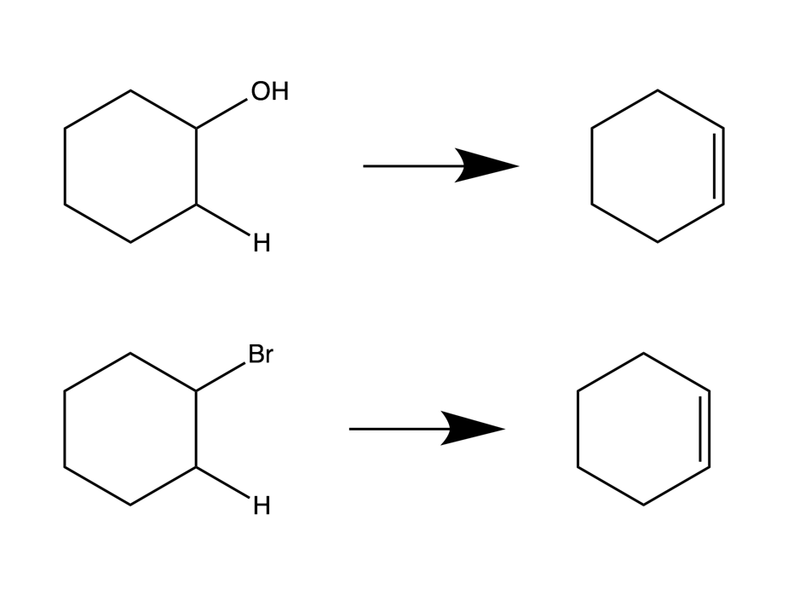

KOH

Heat

H2SO4

50°C

Elimination of the HBr (Br and the adjacent H) occurs by using a strong base and heat

Elimination of the H2O (OH and the adjacent H), occurs by using a strong acid and heat

**Alkene Reactions**

1. Halogenation

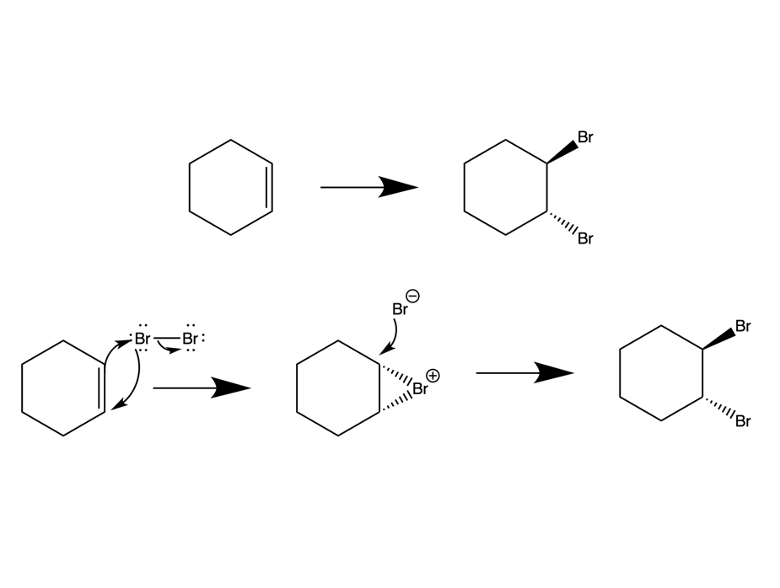

Br2

CH2Cl2

Cyclic ion: bromonium cation (chloronium of Cl2 was used). Considered an anti- addition, and only Br2 or Cl2 can be used (no I2 or F2).

Mechanism:

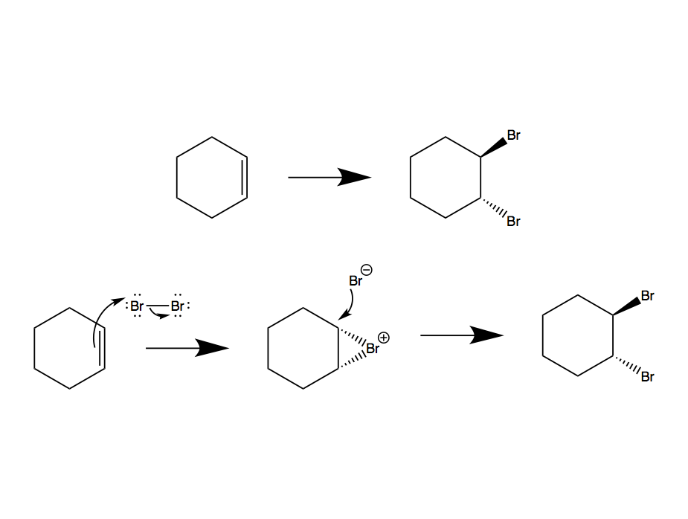

1. Halohydration

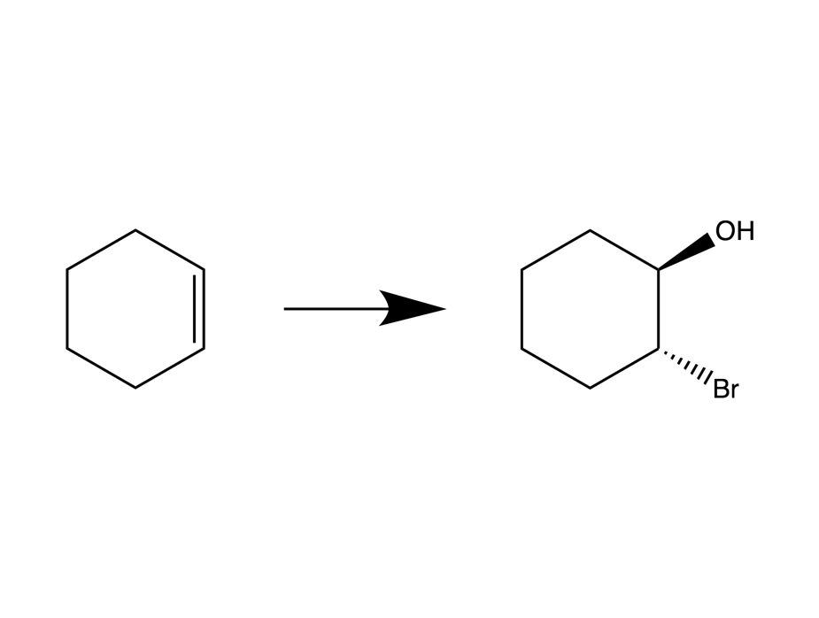

H2O

Br2

Considered an anti- addition (-trans product formed). NBS can be used as a supply of Br as well.

Mechanism:

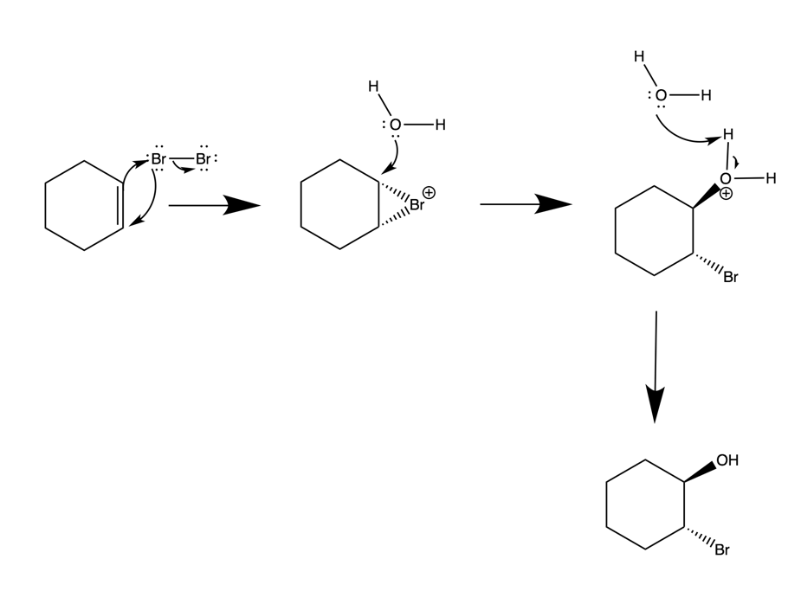

1. Hydration
   1. Acid-Catalyzed Hydration

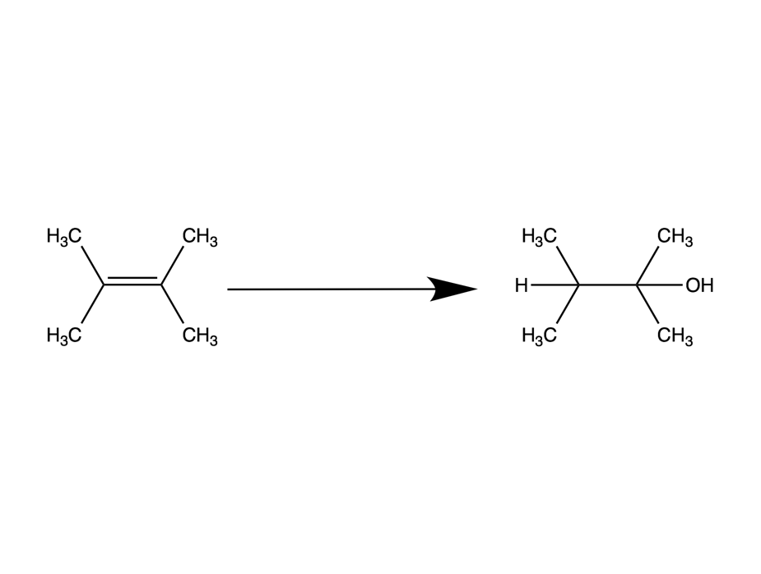

250°C

H2O / H3PO4

Mechanism:

Either H2SO4 or H3O+ could be used as the acid. The acid in the reaction acts as a catalyst.

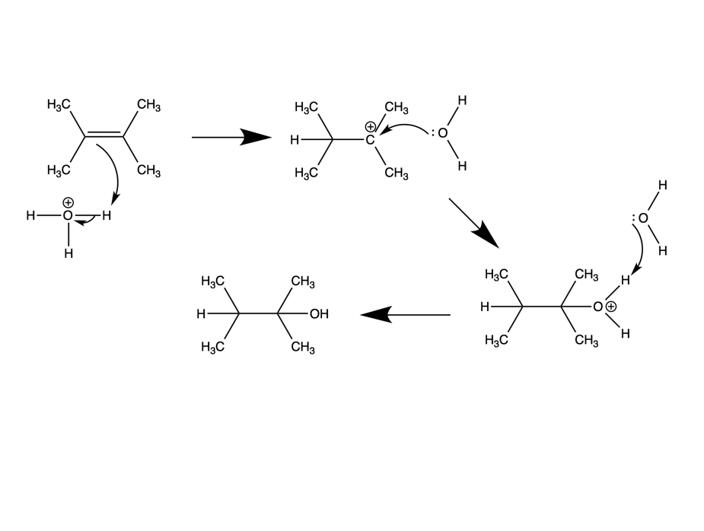

* 1. Oxy-mercuration

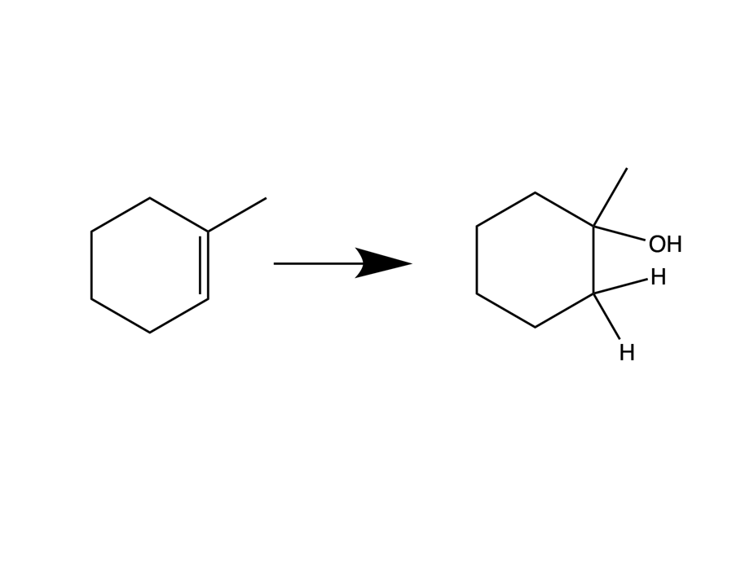 

1. NaBH4
2. Hg(OAc)2 / H2O / THF

Mechanism:

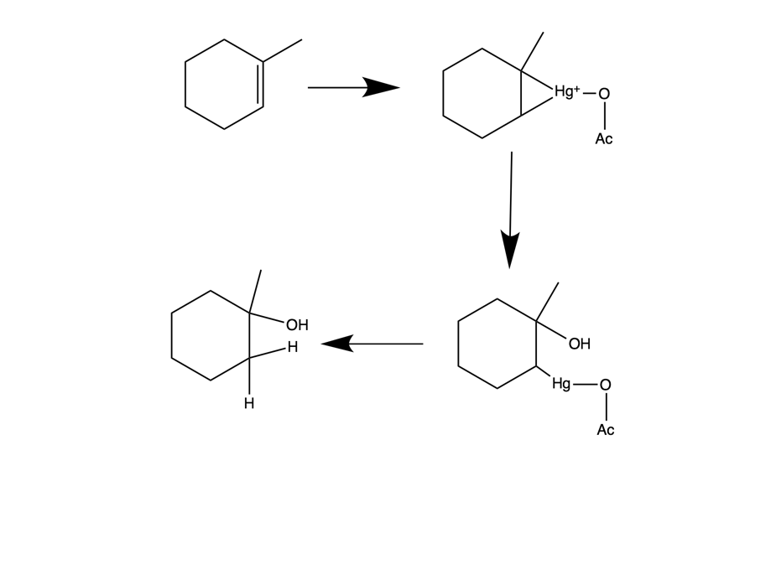

H2O

Oxy-mercuration is a Markovnikov reaction, the –OH group attaches to the more substituted carbon.

* 1. Hydroboration

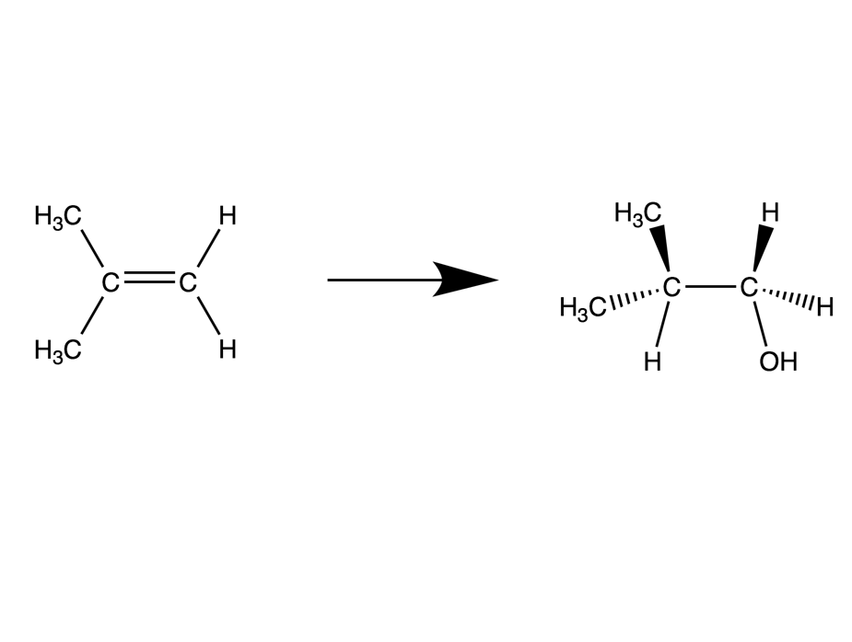

1. H2O / H2O2 / NaOH
2. BH3 / THF

Hydroboration is non-Markovnikov, because the –OH group attaches to the least substituted carbon. In the mechanism, there is a cyclic intermediate, in which the pi bond and sigma bonds are in the process of both forming and breaking.

Mechanism:

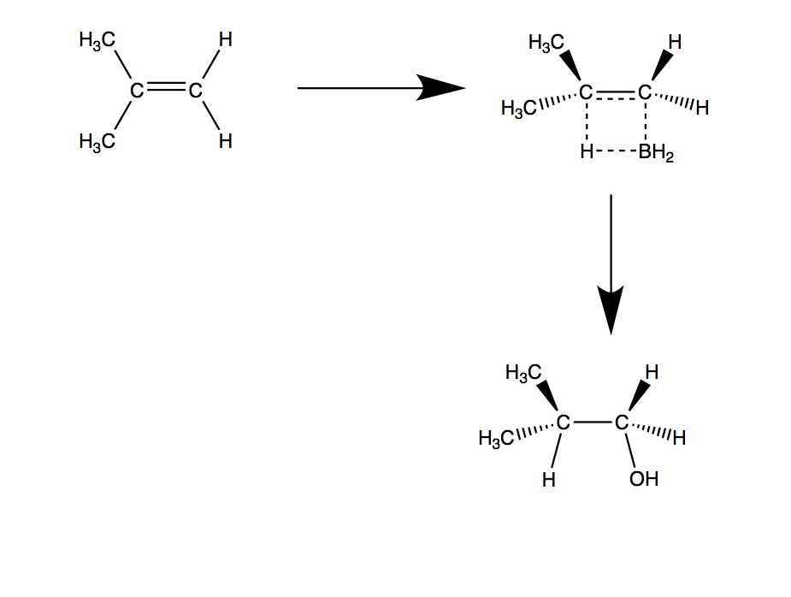

1. Hydrogenation

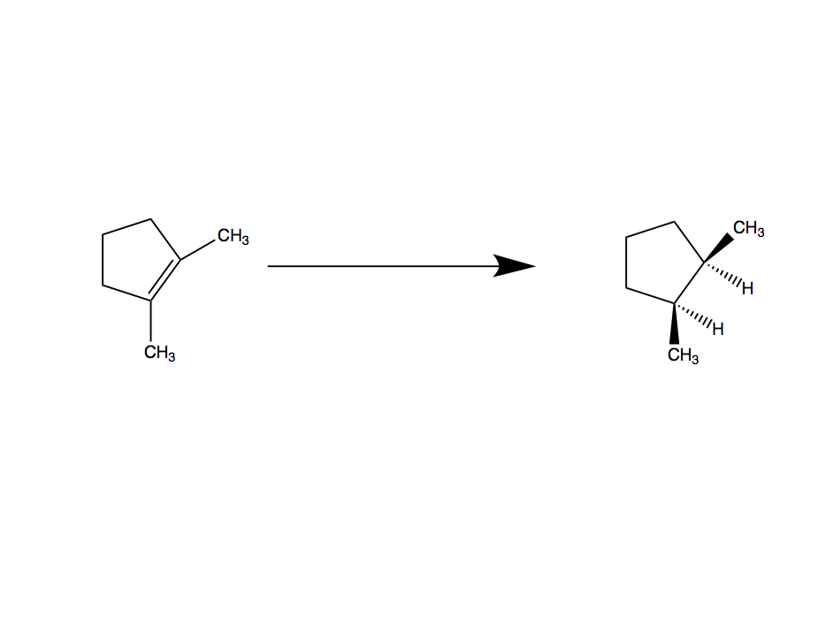

CH3CO2H

H2 / PtO2

Hydrogenation involves the breaking of the alkene pi bond and the syn addition (cis-) of two hydrogens. If the molecule has a “face” or “side” that is hindered by steric strain, the hydrogen atoms will attach to the opposite face of the larger functional groups. H2 Pd/C can also be used to generate the same products.

1. Oxidation

Epoxidation forms a cis- epoxide ring that is attached to the original alkene functional group (the pi bond was broken in the formation of the epoxide). The reagent normally used is MCPBA.

* 1. Epoxidation

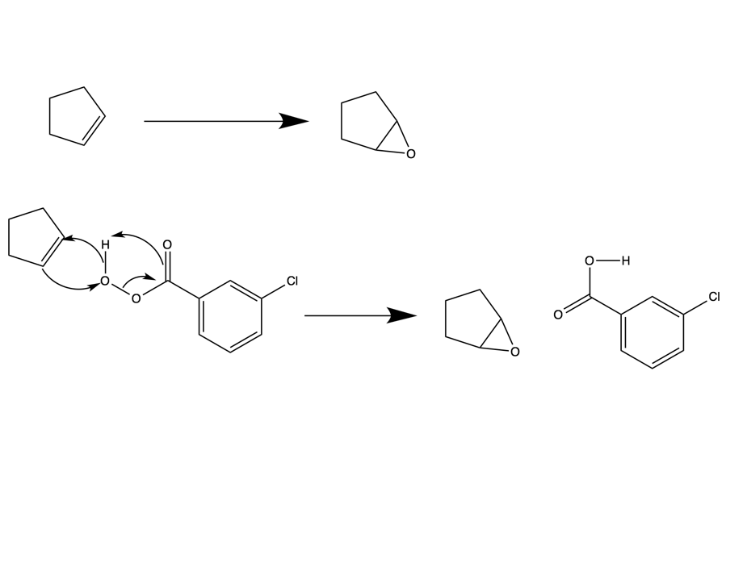

mCPBA

CH2Cl2

Mechanism:



* 1. Hydroxylation (Diol Formation)
     1. Trans- Diol Formation

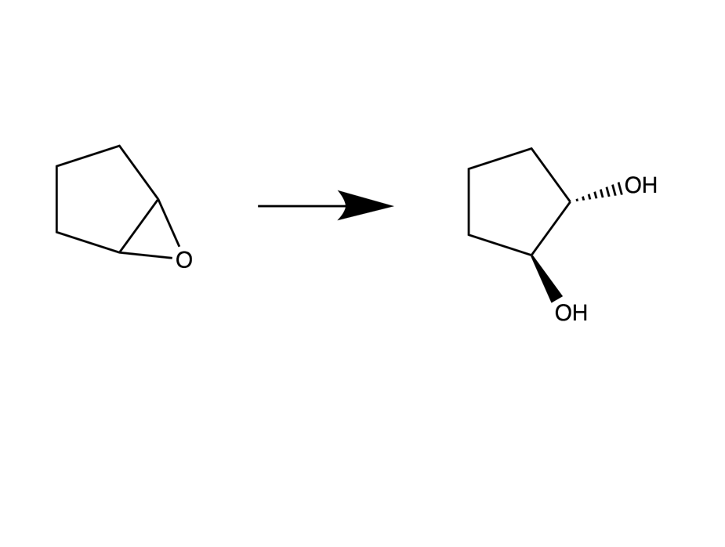

Trans diols are formed from epoxides (if given an alkene, must first generate an epoxide).

H3O+

* + 1. Cis- Diol Formation

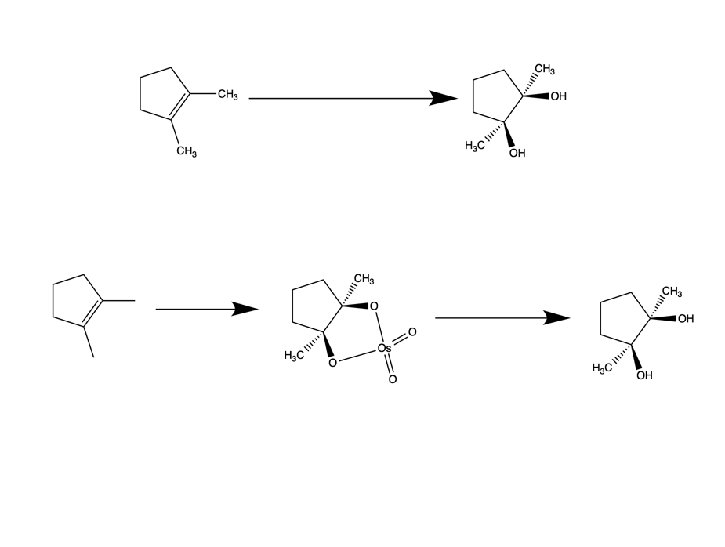

1. NaHSO3 / H2O
2. OsO4 / Pyridine

Cis diols are formed from alkenes using osmium tetroxide to form a cyclic intermediate.

Mechanism:



* 1. Ozonolysis

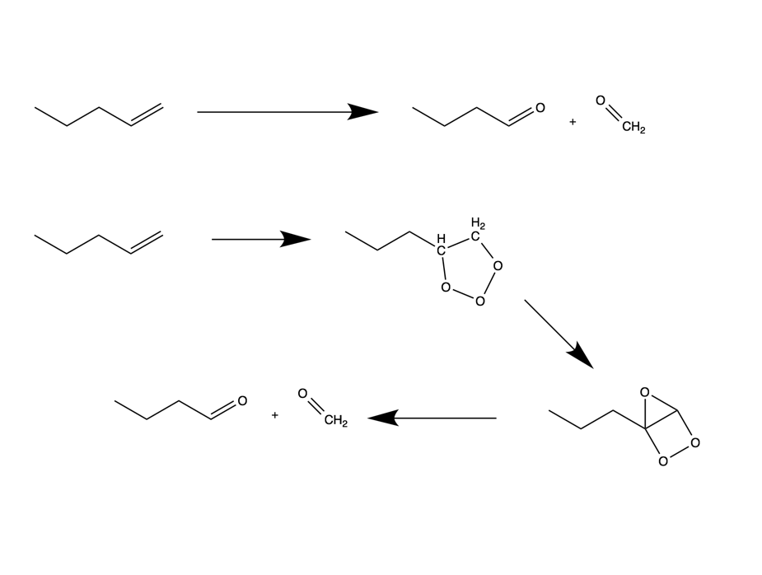

1. Zn, CH3CO2H, H2O
2. O3, CH2Cl2, -78°C

Ozonolysis results in the cleavage of the pi bond in the alkene functional group, forming carbonyls at each of the carbons previously participating in the double bond. Consider symmetry of the molecule in ozonolysis.

Mechanism:

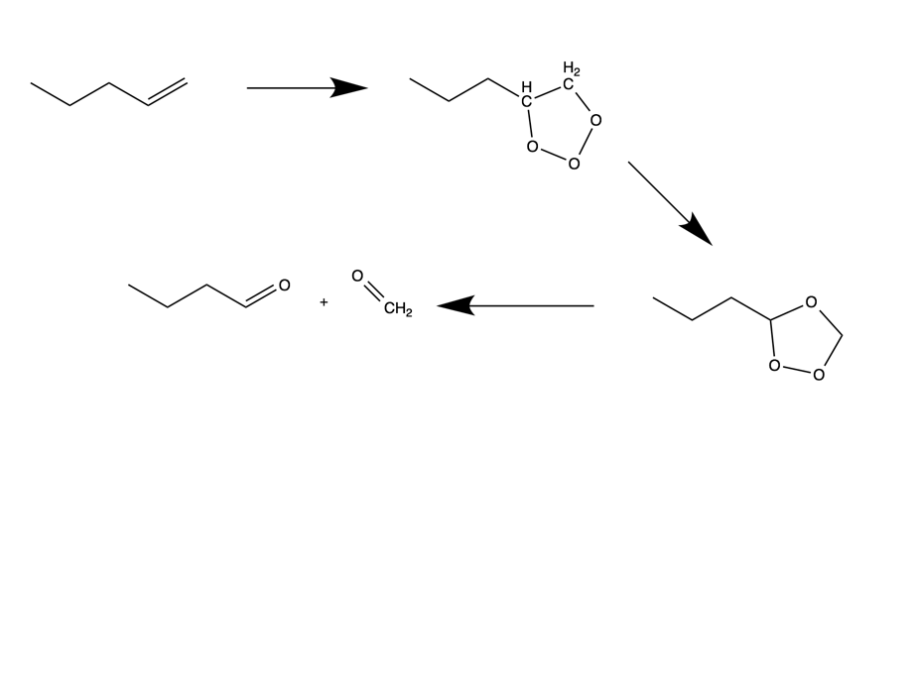

* 1. Permanganate Cleavage

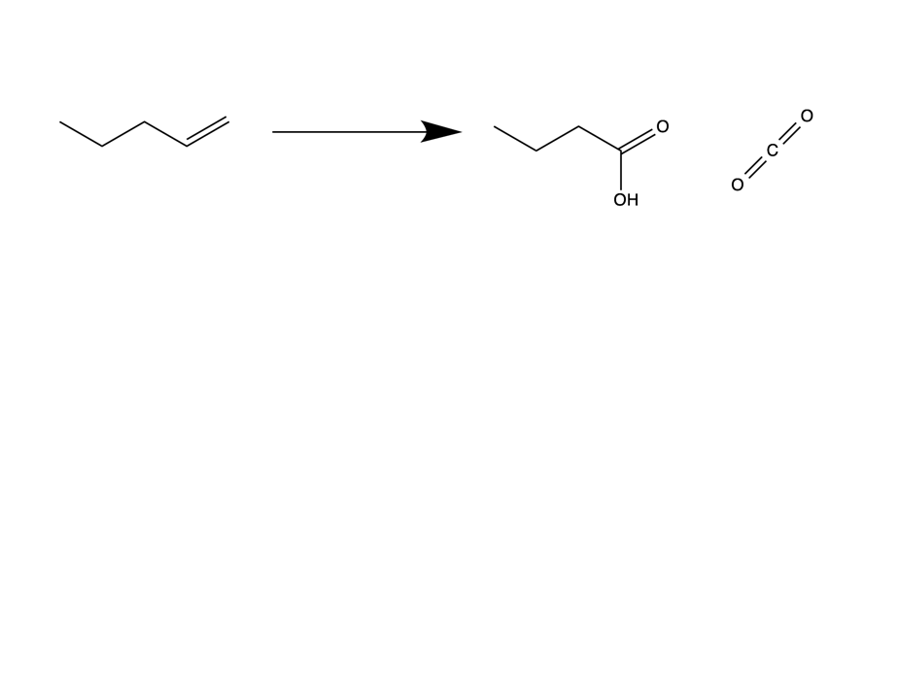

Permanganate is an extremely strong oxidizing agent, meaning that if there are any remaining hydrogens on the carbons once the double bond is broken, the permanganate will replace the hydrogen with a hydroxyl group (1 H present) or a carbonyl group (2 H present).

H3O+

KMnO4

* 1. Diol Cleavage

Diol cleavage is performed with cis- diols (the reaction will proceed extremely slowly if the diol is trans-). The pi bond in the alkene breaks, and a carbonyl is formed on both of the carbons originally in the double bond. The product of diol cleavage also looks identical to the products of the ozonolysis reaction.

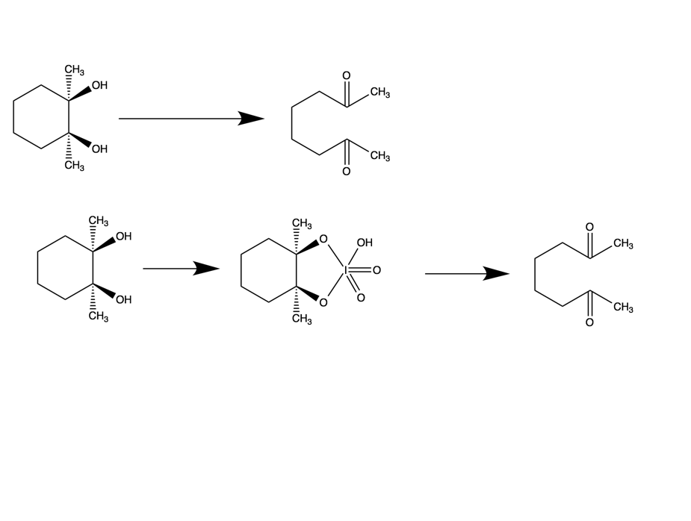

HIO4, H2O, THF

Mechanism:

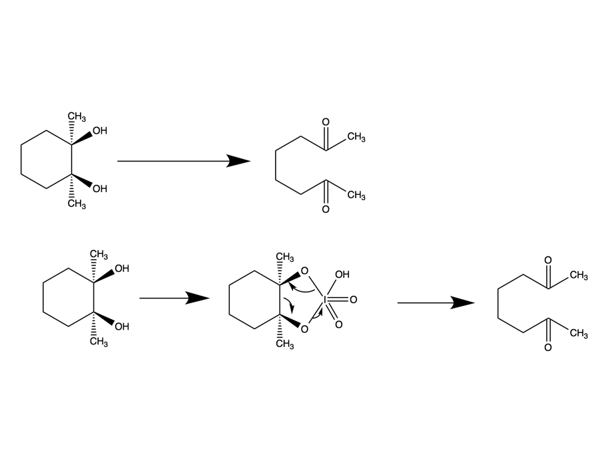

HIO4 /

H2O /

THF

1. Carbene Addition
   1. Dichlorocarbene Addition

The reagents for the dichlorocarbene reaction form the carbene itself, which then reacts with the alkene to form the cyclic structure.

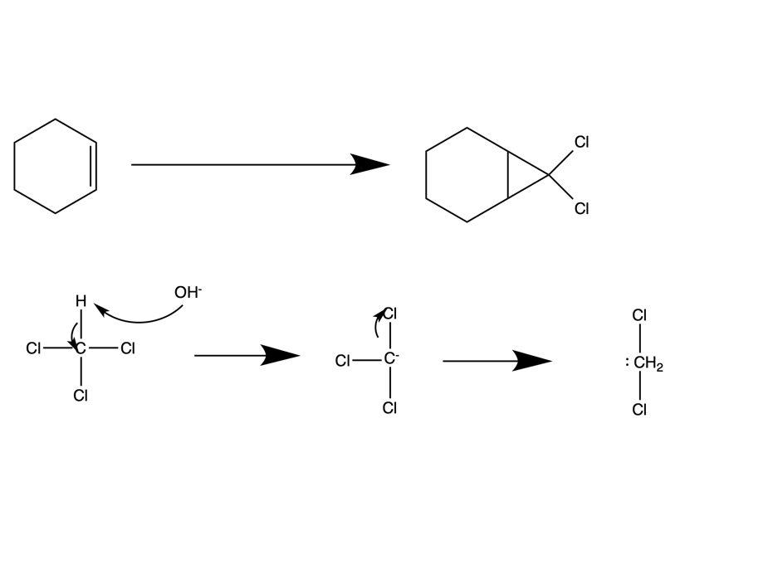

KOH / CHCl3

Mechanism:



* 1. Simmons Smith Reaction

Once again, the reagents are used to create a carbenoid (that acts like a carbene), which will then react with the alkene to form the cyclopropane substituent.

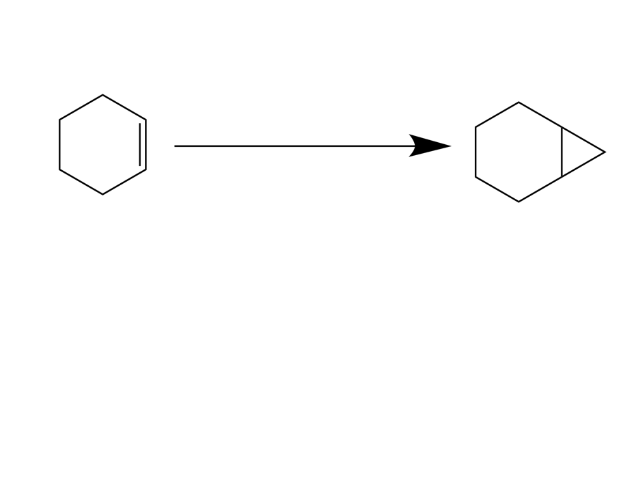

CH2I2 / Zn (Cu) / ether

1. Radical Polymerization

In radical polymerization, a radical, such the radical phenyl group, is created. The radical will then react with the alkene in order to form yet another radical, that can continue to react with alkene functional groups to create a long chain of monomers strung together to form a polymer.

