Chapter 17 Review Packet

**Properties of Alcohols and Phenols**

Alcohols and Phenols have OH functional groups attached to a parent chain (a benzene ring in phenols). The oxygen is an electronegative atom, which makes the rest of the molecule, including the hydrogen it is attached to, polar and/or electron poor. The alcohol group can act as either an acid or a base, by performing a nucleophilic attack with the lone pair on the oxygen, or by donating the hydrogen the oxygen is bound to. The oxygen has the potential to pull electrons from nearby groups, making the hydrogen positively charged. In the acid-base reaction, when the hydrogen is donated, the oxygen anion is formed. The stability of the anion determines the overall acidity of the molecule. If the anion is stable, the reaction yielding the anion as a product will be more favorable. However, if the anion is unstable, the reaction will be less favorable, and pushed to the “left”, making the molecule less acidic.

There are several factors that affect the acidity of an alcohol/phenol. The presence of electron withdrawing groups (EWGs) and electron donating groups (EDGs) have a huge impact on the acidity of the alcohol/phenol. If EWGs, such as halogens, are present, the electrons will be pulled away from the oxygen in the anion form, de-localizing the negative charge, and making the anion more stable. The more electronegative the halogen is (such as F), the greater stabilizing effect it will have on the anion. Also, the closer the halogen is to the oxygen anion (on the parent chain), the more pronounced the electron withdrawing effect will be. The EDGs are mainly methyl groups, which push electrons away from themselves, towards the oxygen anion. This localization of electrons increases the charge of the anion, which lowers the overall stability of the anion, making the molecule less acidic.

Steric hinderence also plays a role in the acidity of alcohols and phenols. If large substituents, such as tert-butyl groups, are present within the molecule, the solvent won’t be able to stabilize the intermediate. The solvent can exert an effect on the anion, stabilizing it. If the alcohol has a small number of substituents, then it can be more easily solvated, and be more stable, making the reaction more favorable. The basic trend is the more large substituents a molecule has, the less stable the anion is (due to the lack of solvation).

**Preparation of Alcohols and Phenols**

1. From Alkenes
   1. Acid-Catalyzed Hydration

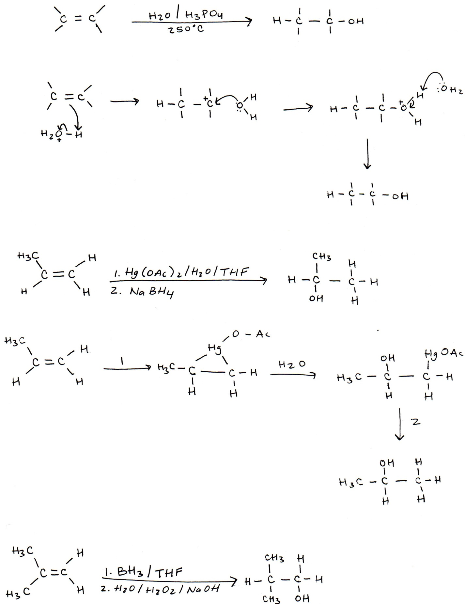

Either H2SO4 or H3PO4could be used as the acid. The acid in the reaction acts as a catalyst.

Mechanism:

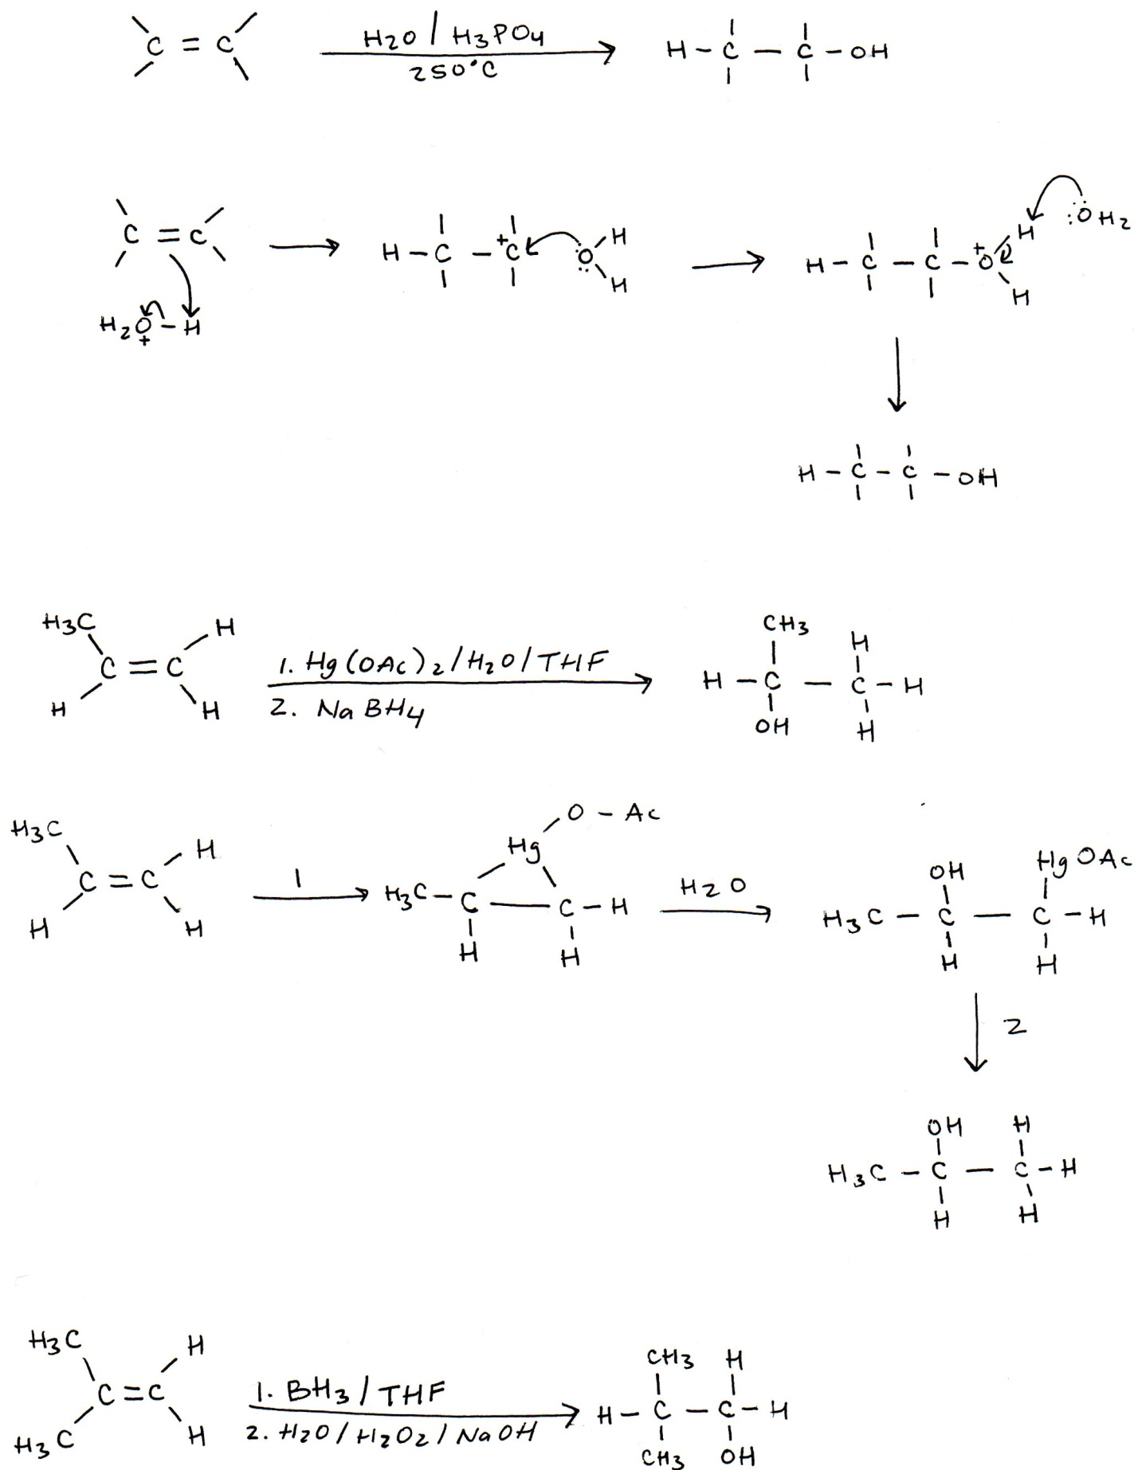

* 1. Oxy-mercuration



Mechanism:

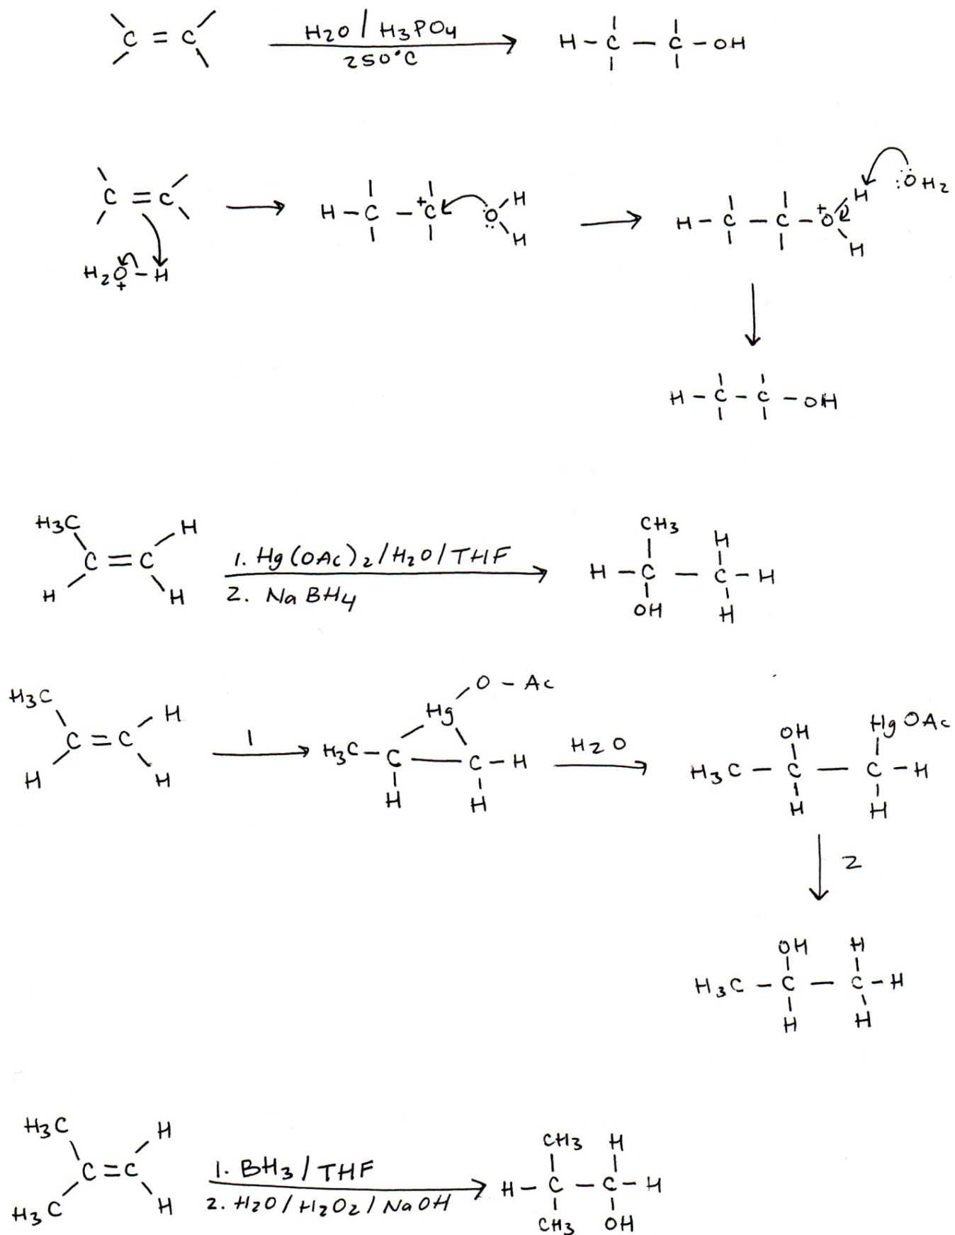

+

Oxy-mercuration is a Markovnikov reaction, the –OH group attaches to the more substituted carbon.

* 1. Hydroboration



Hydroboration is non-Markovnikov, because the –OH group attaches to the least substituted carbon. In the mechanism, there is a cyclic intermediate, in which the pi bond and sigma bonds are in the process of both forming and breaking.

Mechanism:

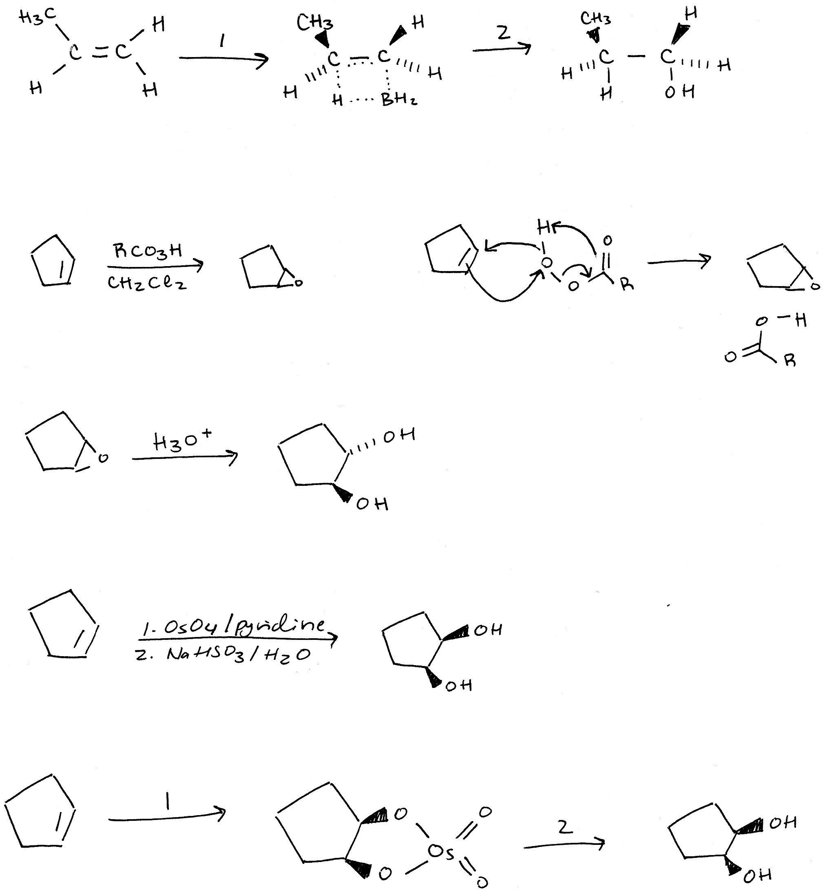

* 1. Trans- Diol Formation



Mechanism:

Trans diols are formed from epoxides (if given an alkene, must first generate an epoxide). MCPBA is the reagent of choice.



* 1. Cis- Diol Formation



Mechanism:



Cis diols are formed from alkenes using osmium tetroxide to form a cyclic intermediate.

1. From Carbonyl Compounds (Reduction)

Basic Mechanism:

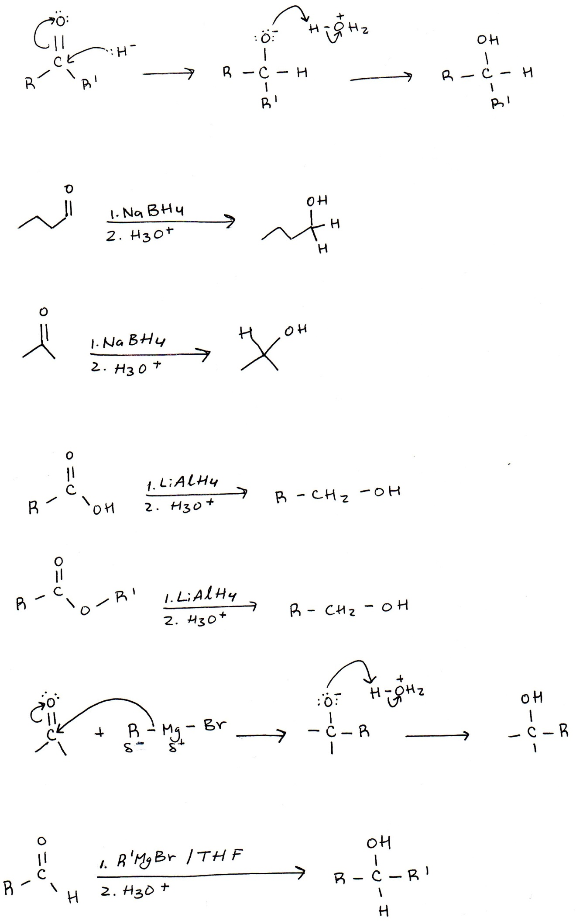

* 1. Aldehydes



LiAlH4 is a much stronger reducing agent than NaBH4, which can only reduce aldehydes and ketones.

* 1. Ketones



* 1. Carboxylic Acids and Esters



Carboxylic acids and esters, when reduced, will form primary alcohols.



+ R1--OH

1. From Grignard Reactions:

Basic Mechanism:



* 1. Aldehydes



* 1. Ketones

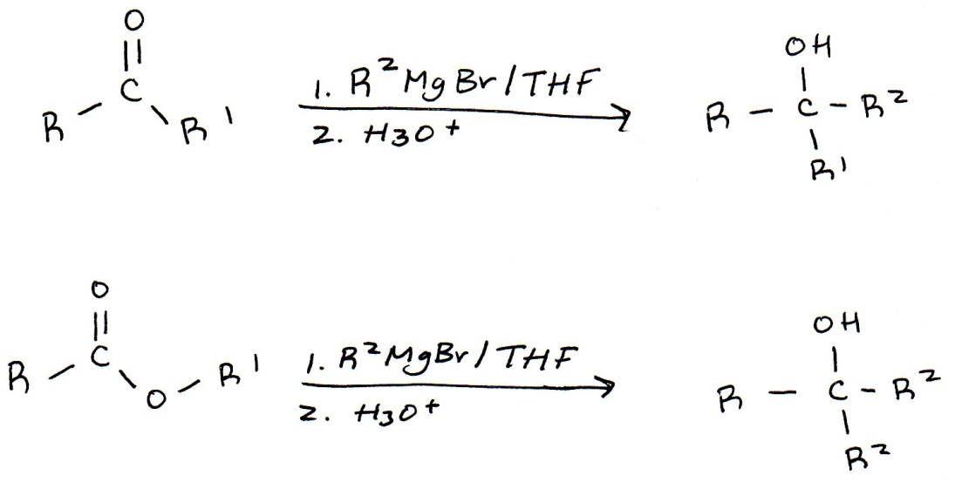

* 1. Esters

In the Grignard reaction, esters will form tertiary alcohols with two additions of the Grignard alkyl group.

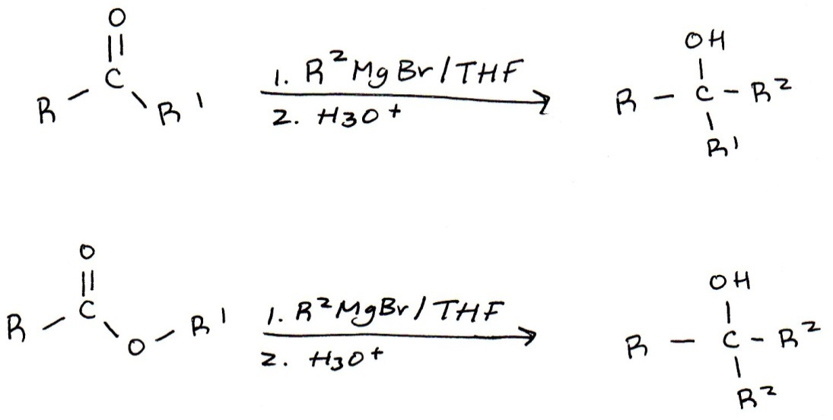

+ R1--OH

**Reactions of Alcohols**

1. Formation of Organohalides
   1. For Tertiary Alcohols:

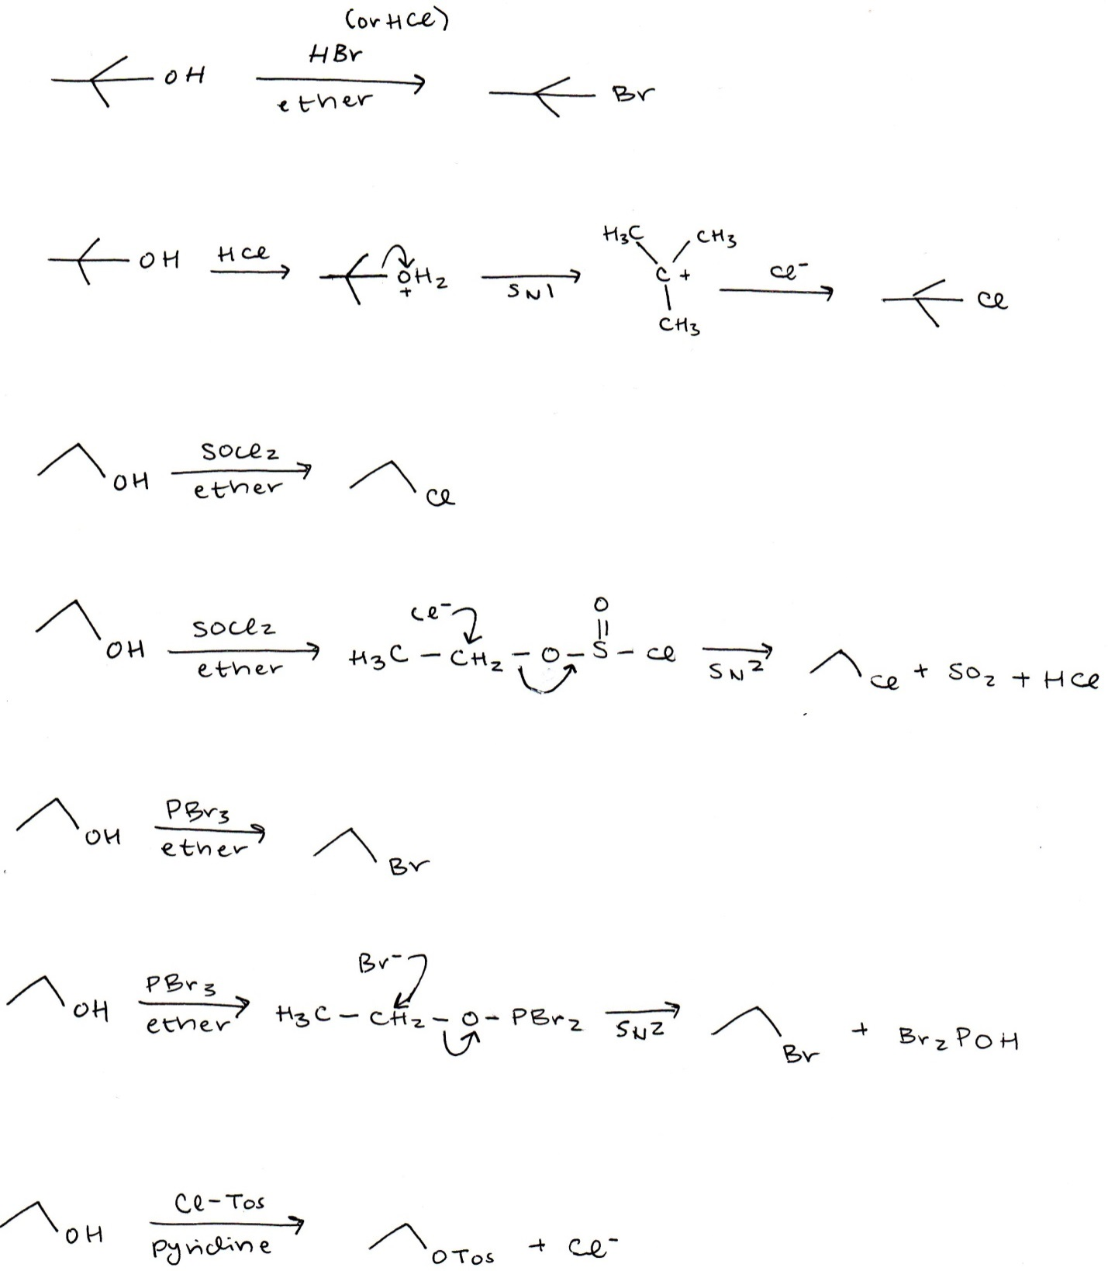

The oxygen is first protonated, so an SN1 reaction can be performed.

Mechanism:



* 1. For Secondary or Primary Alcohols:

The Halogenation of secondary and primary alcohols can result in an inversion of configuration if the carbon bound to the alcohol group is a chirality center.



Mechanism:

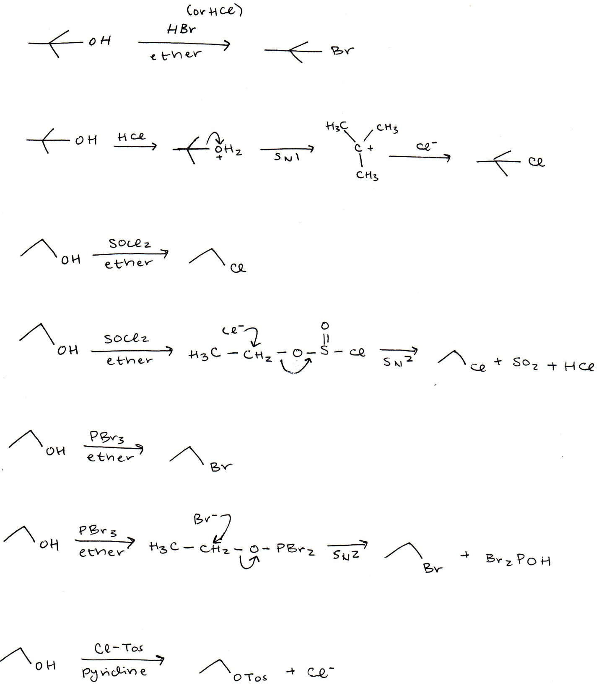



Mechanism:



1. Conversion to Tosylate



Conversion to a tosylate will not result in an inversion of a configuration, even if the carbon is a chirality center within the molecule.

1. Dehydration (formation of alkenes)

This reaction proceeds according to Zaitsev’s rule, which is why the major product is the more substituted alkene.

* 1. For Tertiary Alcohols

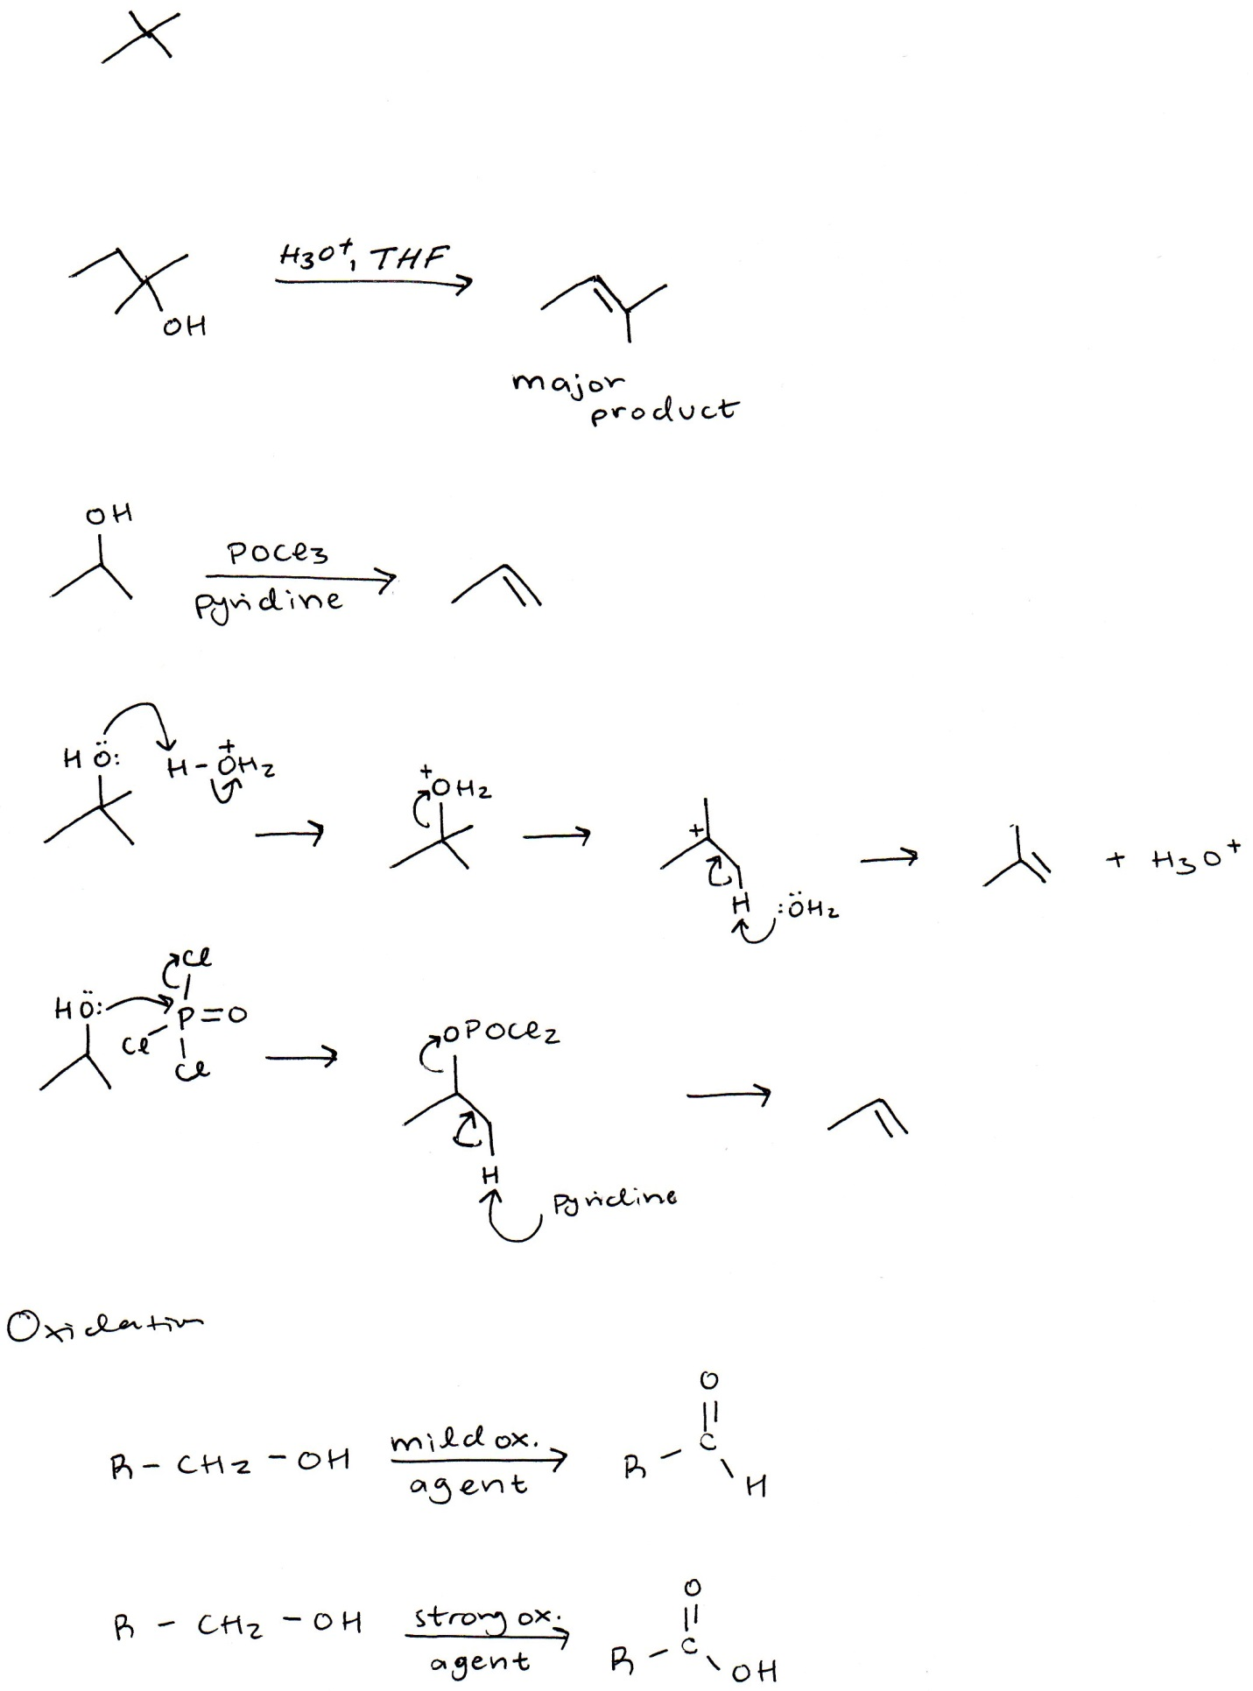

Mechanism:

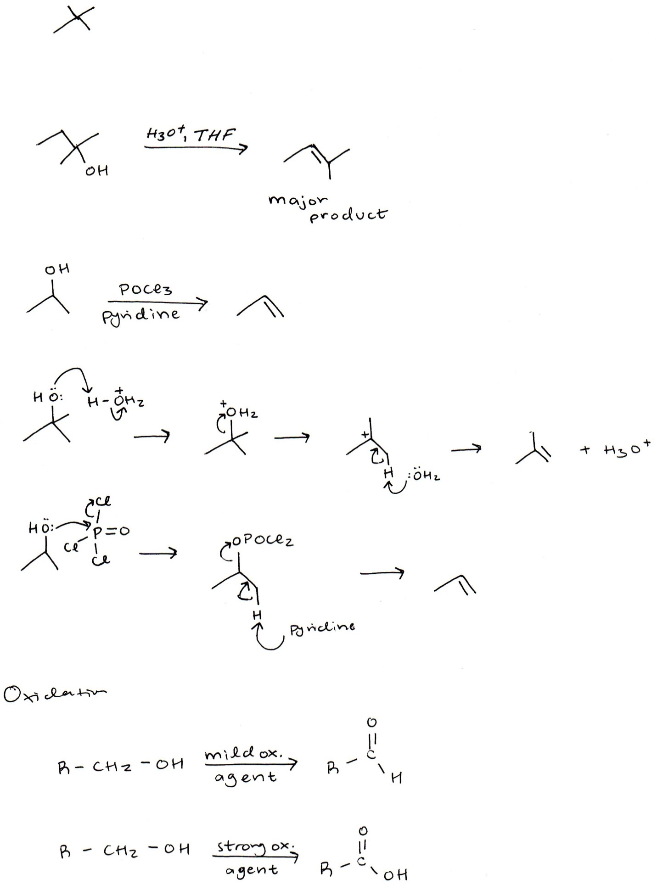

* 1. For Secondary and Primary Alcohols



Pyridine acts as the base that pulls off the hydrogen, initiating the formation of the pi bond.

Mechanism:



1. Oxidation Reactions
   1. For Primary Alcohols





* 1. For Secondary Alcohols

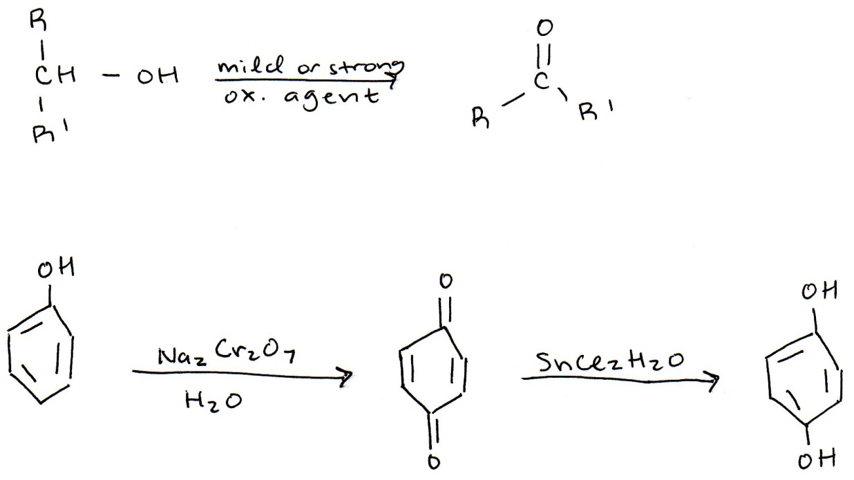

* 1. For Tertiary Alcohols
     1. No reaction occurs with tertiary alcohols, they cannot be oxidized.

**Strong Oxidizing Agents:**

CrO3, Na2Cr2O7, KMnO4

**Mild Oxidizing Agents:**

PCC, Cr (VI), DMP

**Reactions of Phenols**

1. Oxidation of Phenols (and Reduction)

