Chapters 4,5,6,7 Test Review

1. Name the following cycloalkanes:

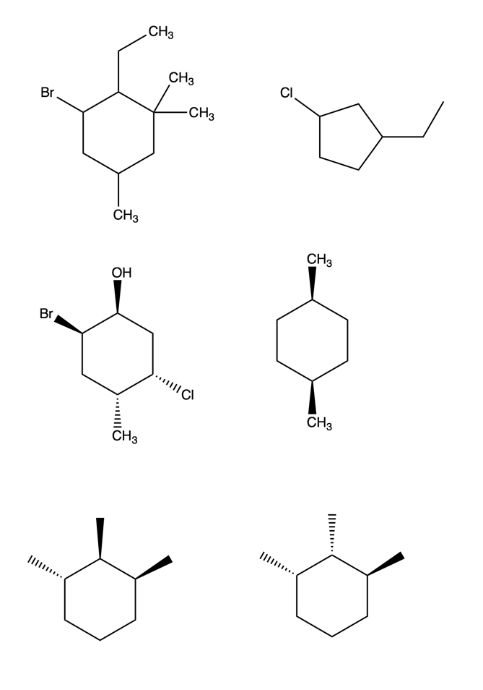 

1. Circle and state the number of chirality centers in the following molecules:

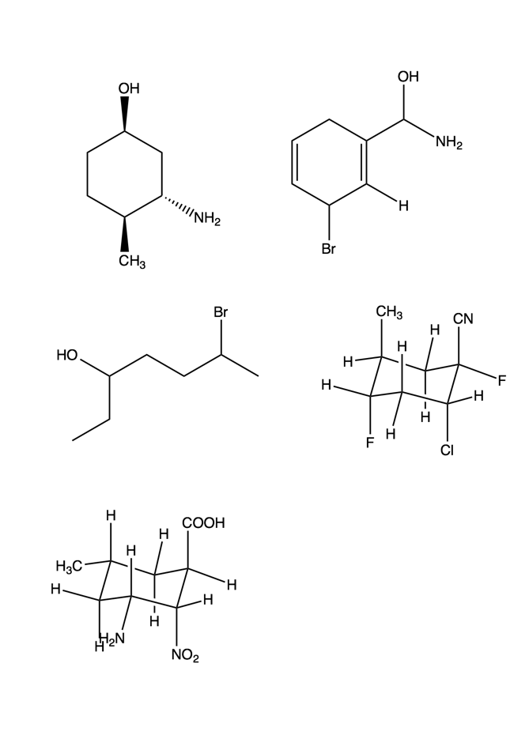 

1. From the following molecules, which conformer has the lowest energy?

 

1. State whether the following molecules are enantiomers or diastereomers.

 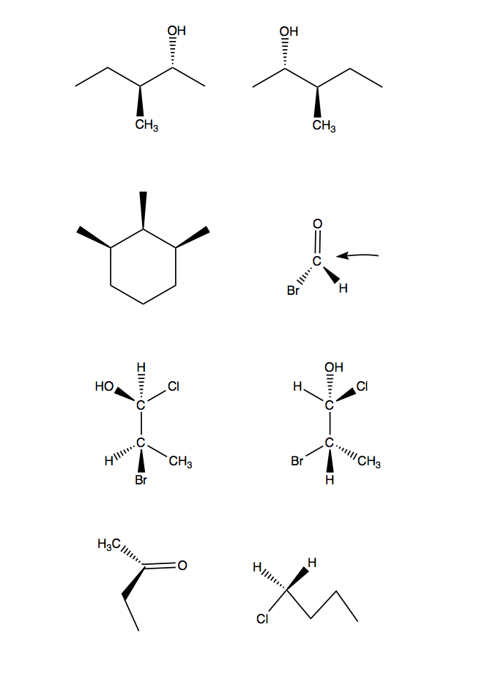

 

 

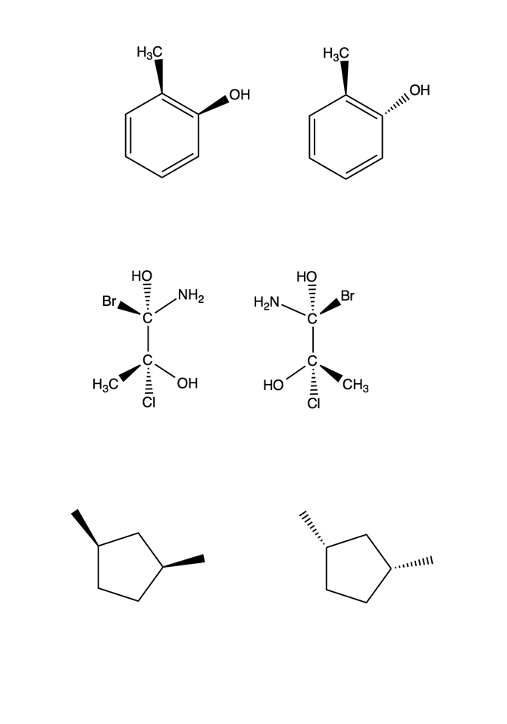

1. Assign pro-chiral faces for the following molecules (according to the arrows):

 

1. Assign pro-chirality to each of the hydrogen atoms in the following molecules:

 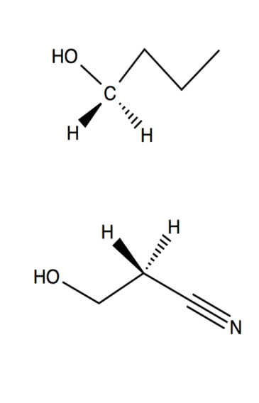

1. Circle parts of the following molecules that could be considered electrophiles/ nucleophiles.

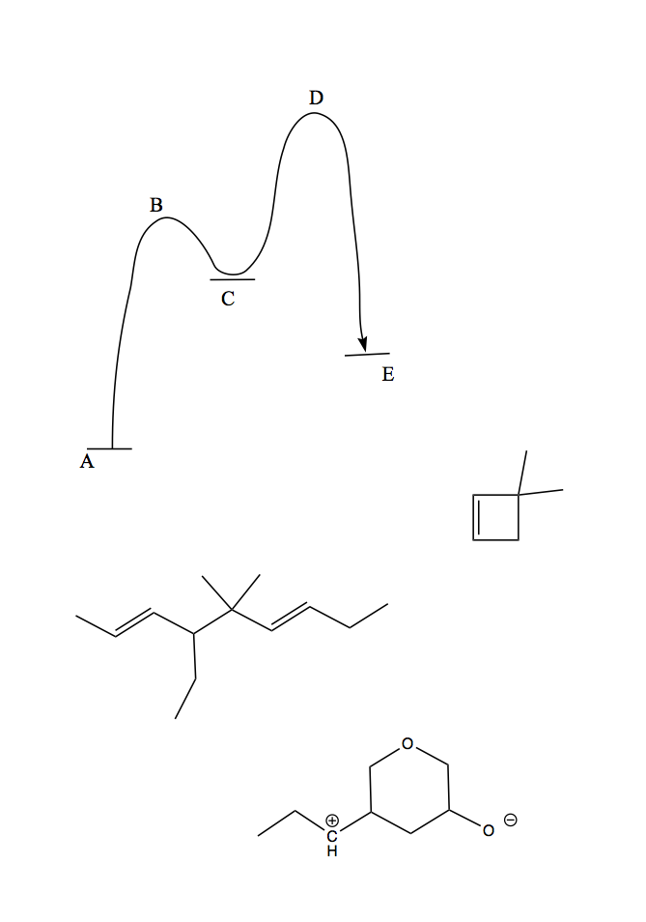

1. Classify the following reactions as addition, elimination, substitution or rearrangement:

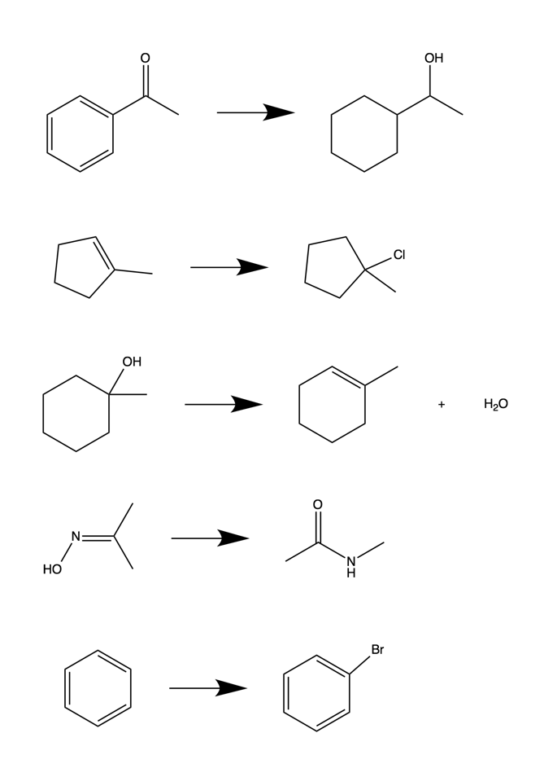









1. An unknown reaction occurs with a Keq of 106.3, what does this imply for the type of reaction (spontaneity, endergonic or exergonic, etc.)?
2. Label the parts of the following energy profile:



1. What are the degrees of substitution for the following molecules?

C5H7Br3O2

C7H8N2O

C12H18Cl3N

1. Name the following alkenes:

 

1. Draw out the molecules that correspond to the following names:

(1E) 1-bromo-3-ethyl-4,6-dimethyl-octene

(2Z,5E) 2-chloro-5-methyl-2,5-octadiene

1. Draw out a mechanism for the following reaction:

